Assignment 3.2 Reflection - Krish Thapa
Page 1:
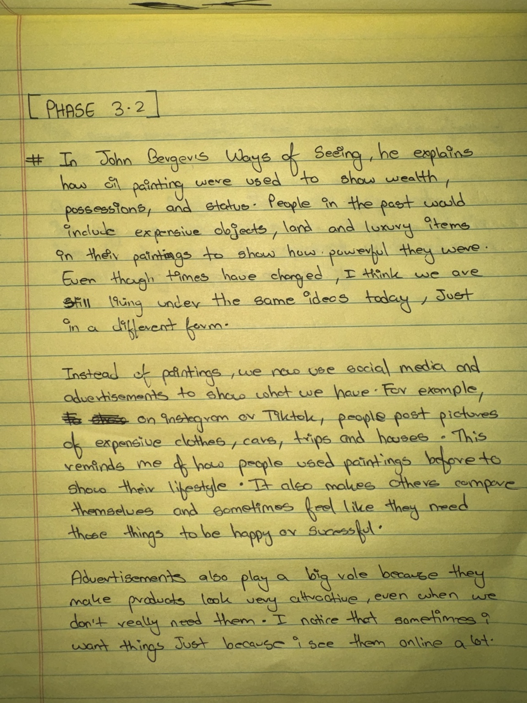

Page 2:
